**Software Development Forum**

**Room 044, Gate 4, Principality Stadium, Cardiff, CF10 1NS.**

**Thursday 7 March 2019**

**10:00 to 15:30**

|  |  |  |  |
| --- | --- | --- | --- |
| 09:30 |  | Arrival and refreshments |  |
| 10:00 | 1 | Introductions and apologies | Gareth Thomas |
| 10:05 | 2 | Minutes of 7 February 2019 meeting and actions update | Gareth Thomas |
| 10:15 | 3 | Sex/gender identity data collection update | Gav Elias |
| 10:30 | 4 | Free school meals and transitional protection update | Gav Elias |
| 10:45 | 5 | SWAC update:   * Contingency spreadsheets * Pilot | Gareth Thomas |
| 11:00 | 6 | PLASC lessons learned workshop | Alice De’Abreu |
| 11:15 | 7 | S2S – open discussion | Gav Elias |
| 12:15 | 8 | Terms of Reference update | Gav Elias |
| 12:30 |  | Lunch |  |
| 13:15 | 9 | Curriculum and assessments development and recording progress workshop | Gav Elias |
| 13:30 | 10 | Additional Learning Needs and Education Tribunal (Wales) Act 2018:   * Rollout timetable * Reporting | Bethan Cowan |
| 14:30 | 11 | Performance reporting | Steve Hughes/Sarah Angel |
| 15:00 | 12 | Any other business   * Post-16 XSLT files update * Supplier software codes * SDF development cycle update | Gav Elias/Alice De’Abreu |
| 15:30 |  | End |  |

**Contacts:**

IMS Helpdesk: 0300 062 5014 / [IMS@gov.wales](mailto:IMS@gov.wales)

Gav Elias: 0300 025 6562 / [gavin.elias2@gov.wales](mailto:gavin.elias2@gov.wales)

Alice De’Abreu: 0300 3584 / [alice.deabreu@gov.wales](mailto:alice.deabreu@gov.wales)

Chloë Harris: 0300 025 0182 / [chloe.harris@gov.wales](mailto:chloe.harris@gov.wales)

**Parking**: There are several paid parking areas surrounding the venue as marked on the below localised map. In addition to the below, there is an abundance of street parking within 5-10 minutes walk of the stadium that can be paid for using roadside parking meters or the MiPermit smartphone app or website, which may be cheaper than the NCP multi-storey car parks. You can find the MiPermit website at <https://www.mipermit.com/>.

**NCP, Westgate Street to Gate 4**

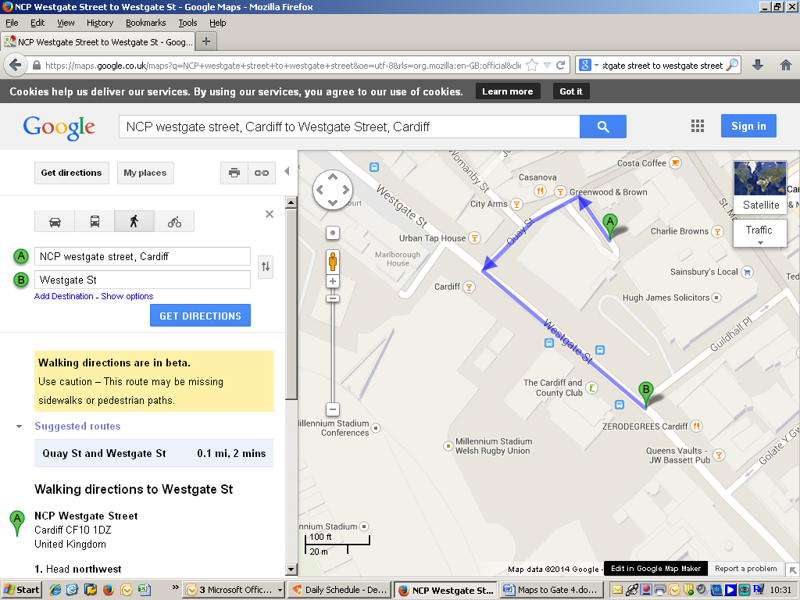

Principality stadium

|  |
| --- |
|  |
|  |  |  |
|  |  |  |
|  | **1.** Head **south** toward **Quay St**  **2.** Turn left onto **Quay St**  **3.** Continue onto **Westgate St**  **3.** Proceed left until you reach **Zero degrees** on the left  **4.** Look right you have reached the **Principality stadium**  **5.** Proceed down the ramp to **Gate 4** |  |

**Cardiff Central Train Station to Gate 4**

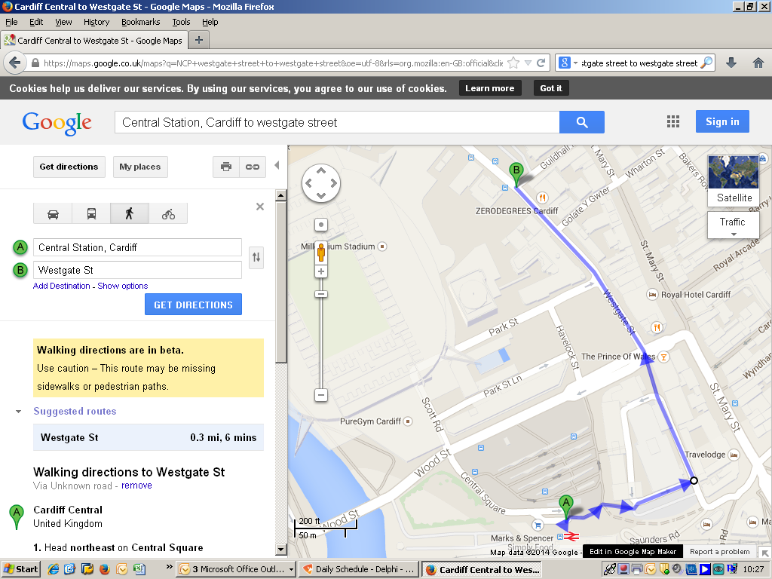

**1.** Head **northeast** on **Central Square**

**2.** Turn right towards **Great Western Ln**

**3.** Turn right towards **Great Western Ln**

**4.** Turn left towards **Great Western Ln**

**5.** Turn left towards **Great Western Ln**

**6.** Turn left onto **Westgate St**

**7.** Proceed until you reach **Corado Bar** on the right

**8.** Look left you have reached the **Principality Stadium**

**9.** Proceed down the ramp to **Gate 4**